TITLE: Bitcoin Price Prediction Using Machine Learning

Description
Bitcoin is a decentralized cryptocurrency whose price fluctuates daily due to market demand, trading volume, and investor behavior. This project focuses on building a realistic Bitcoin price prediction model using supervised machine learning. Unlike same-day prediction models, this approach predicts the next day’s closing price using previous day market information, thereby avoiding data leakage and making the prediction more practical.

Objective
The objectives of this project are:
- To predict the next day Bitcoin closing price using historical data
- To apply supervised learning regression techniques
- To avoid data leakage by using previous-day features
- To evaluate model performance using standard regression metrics

Problem Type
- Regression Problem
- The output variable (Bitcoin closing price) is a continuous numerical value, hence regression is used.

Prediction Type
- Time-series based price prediction
- Predicting today’s Close price using yesterday’s Close and Volume

Model Used
- Linear Regression
  - Supervised learning algorithm
  - Learns a linear relationship between previous market features and current price
  - Simple, interpretable, and suitable as a baseline model

Dataset Description
The dataset contains historical Bitcoin market data with the following attributes:
- Date
- Open
- High
- Low
- Close (Target variable)
- Volume
From this dataset, new features are engineered:
- Prev_Close – Previous day closing price
- Prev_Volume – Previous day trading volume

Workflow / Methodology
- Import required Python libraries
- Load Bitcoin historical dataset
- Convert Date column to datetime format
- Create previous-day features using shift operation
- Remove missing values
- Select features and target variable
- Split data into training and testing sets (without shuffling)
- Train Linear Regression model
- Predict Bitcoin prices on test data
- Evaluate model using MAE, RMSE, and R² score
- Visualize actual vs predicted prices
- Predict next day Bitcoin price

Code Snippet (Core Logic)
df['Prev_Close'] = df['Close'].shift(1)
df['Prev_Volume'] = df['Volume'].shift(1)
df.dropna(inplace=True)

X = df[['Prev_Close', 'Prev_Volume']]
y = df['Close']

model = LinearRegression()
model.fit(X_train, y_train)

y_pred = model.predict(X_test)

Output Expected
- Realistic prediction of Bitcoin closing price
- Moderate prediction error (not unrealistically perfect)
- R² score less than 1 but still high
- Graph showing predicted prices closely following actual prices

Original Output Obtained
From the execution of the model, the following results were obtained:
- Mean Absolute Error (MAE): 1124.14
- Root Mean Squared Error (RMSE): 1633.24
- R² Score: 0.9894
- Predicted Next Day Bitcoin Price:
Predicted Next Day Bitcoin Price: 40043.65 USD
The plotted graph shows that predicted prices follow the actual trend with minor deviations, indicating a realistic and reliable prediction.
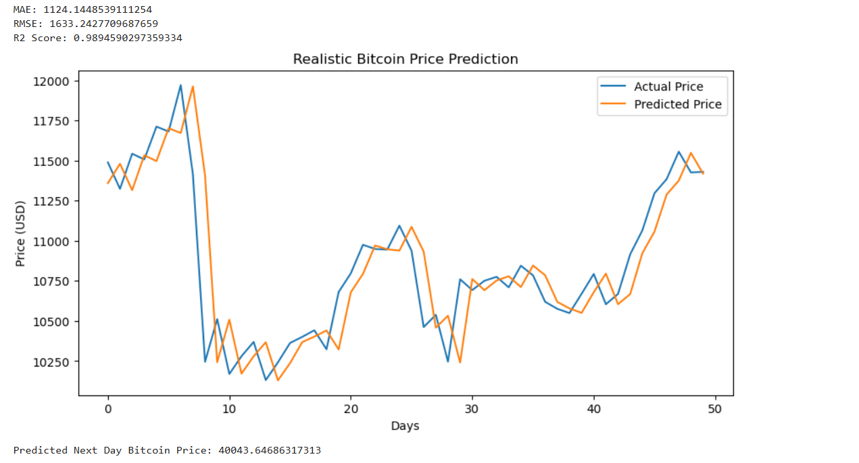
Conclusion
This project successfully demonstrates a realistic approach to Bitcoin price prediction using supervised machine learning. By using previous day closing price and volume, the model avoids data leakage and provides a more practical evaluation of performance. Although Linear Regression performs well as a baseline model, future improvements can be achieved by using advanced algorithms such as Random Forest, Support Vector Regression, or LSTM networks for better handling of non-linear market behavior.

